Our Family’s Lots at Bohemian National Cemetery
Wesley Johnston
October 12, 2005

When I was in Chicago on September 26, we went to Bohemian National Cemetery. We checked at the office and visited four lots of our family, plus a fifth lot (Josef Subrt) that we came upon. I was frustrated that there were so many Mareks and that I had not brought my laptop with the family database, so that we never knew where the parents of Katerina Marek (Mom’s Mom’s Mom = Grandma Subert’s Mother) were buried. So I have done some extensive work at home, using 9 books that I bought in 2001, and this document gives the results of my work.

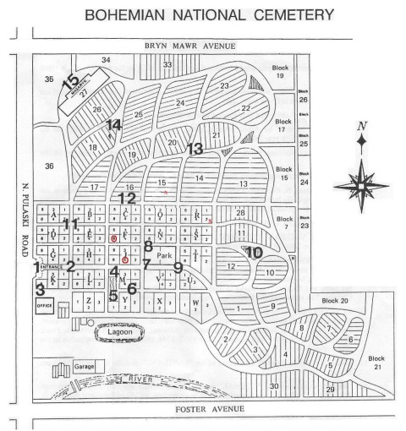
The map marks the blocks (circles) or the more accurate locations (x’s) of the four lots that we visited. Before going into the details of what I found in the 9 books, I will first tell what we found on the headstones at each of these lots. (For information about the big black numbers, see Appendix A.)

1 – Headstones on the Lots We Visited
Lot 3 - Block 6 - Section F (Grandpa & Grandma Subert - Mom has the deed for this lot)
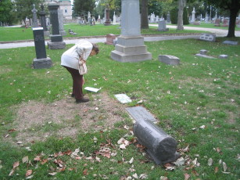
Headstones:
A - Frank J. Subert / Illinois / S2 USNRF / World War I / April 12 1893 - April 22 1954
B - Elsie E. Subert Nov. 12, 1893 - Mar. 26, 1984
C - Josef Mikulecky died 10 May 1920 at age 27 years ("zem 10 kvet 1920 / v stari 27 roku")
He was the son of Mom's GreatAunt Lottie (Klotilda) Marek (sister of Katerina) who married Joseph Mikulecky in 1892. The younger Joseph was the husband of Marie Rezac. He was a structural riveter, who died at the "Post Graduate Hospital" in Chicago of sarcoma of an undescended testicle (duration 2 years) contributed to in the final year by abdominal metasteses = cancer. I don't think he had any children.

Lot 13 – Block 4- Section J (Petr & Katerina (Marek) Koutecky family) and more
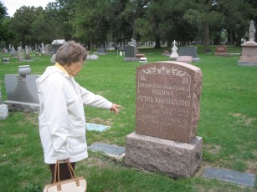
Headstones:
A - Rodina Petra Kouteckyho (Family of Petr Koutecky) - Peter 1851-1936, Katerina 1850-1935, Edward 1887-1906, Jaroslava 1891-1907
These are Grandma Subert's parents and brothers Eddie (killed crossing Michigan Avenue ?near 12th Street?) and Jerry (died of illness). Peter and his first wife came to America, where she died after childbirth and he remarried to Katerina who had come her with her family.
B - Elsie Lillian Vlazny 1911-1964
C - Emily Vlazny 1885-1968
D - Joseph T. Vlzany 1885-1964
These are Mom's Aunt Emma (Grandma Subert's older sister) and her husband Joe and their daughter Elsie, who had palsy all her life.

Lot 4 – Block 2 – Section R (Frank & Marie (Nevole) Subert) and more
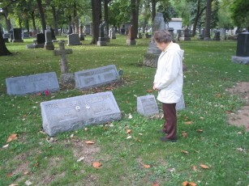
Headstones:
A - Subert - Otec (Father) Frank 1861-1941 - Matka (Mother) Marie 1875-1941 [This stone has their photographs on it, showing almost no wear after all these years.]
These are Grandpa Subert's parents.
B - Anna Subert 1836-1903
C- Frank Subert 1836-1896
These are Grandpa Subert's Father's parents (Mom's grandparents), who brought their family to America. Anna's maiden name was Malypeter. She was born in Msecke Zehrovice, and he was born in Hresice. When they married in 1857, he moved to Msecke Zehrovice.
D - Subert - James 1899-1967 - Anna 1908-2002
These are Mom's Uncle Jim and Aunt Anna, parents of Mom's cousin Anne-Marie. They are the ones who lived near Midway Airport.
E - Stroner - Otec Frank 1859-1937 - Matka Barbara 1866-1940
Barbara Subert was the younger sister of Mom's Father's Father (headstone A). She was born at Msecke Zehrovice in Bohemia on 12 Nov 1864 (and thus shared her birthday with Mom's Mom who was born 12 Nov 1893). They had at least 3 children: Anastazie (1897-1899), Marie (married Krisl), Pauline. There is also a Joseph Stroner, who died after 29 Aug 1837, but I am not sure if he was their son or possibly Frank Stroner's brother. He was the informant on Frank's death certificate, so most likely their son. There is an American Legion Auxiliary marker next to Barabara's side of this stone, so that she must have been in the auxiliary which probably means that Frank Stroner was in WWI and then in the American Legion after the war.

Lot 46 of Section 15 (Mom's Mother's Mother's Brother's family - Joseph Marek and more - Kupka, Warchus)
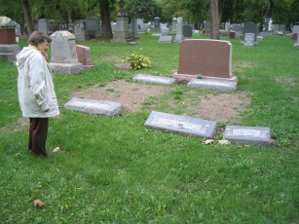
Headstones:
A - Marek - Father Joseph 1855-1910 - Mother Mary 1857-1922
B - Daughter Marie Marek 1884-1916
C - Marek - Son Emil 1882-1959 - Son Henry 1887-1921
This is the family of Mom's Mom's Brother. They had at least 6 kids: Joseph B. (married Carolina Reznick; had at least 4 kids, of whom Raymond was born about same time as Mom), Emil, Vlasta (married Hayda; had at least 4 kids, including Florence), Libby (married Kupka), Blanche (married Warchus; had no children), and Jerry J. (died 1963; married Francis Cill - had daughter Muriel Marek). So the Henry who we found on the stone, died 1921, is a 7th who was not in my database.
D - Kupka - Father Charles 1885-1977 - Mother Libby 1889-1963
E - Warchus - Blanche 1892-1967 - William 1886-1973
These were daughters of Joseph and MAry (headstone A).

A Fifth Lot (Subrt) That We Discovered
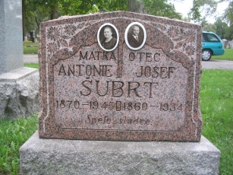
Near the 4th lot, in Section 15, we also found a Subrt grave that I do not know how -- or if -- it fits in. It is a very nice stone, with photos:
SUBRT - Matka Antonie 1870-1945 - Otec Josef 1860-1934
Josef’s birth in 1860 puts him in the era of Mom's Father's Father (the Frank Subert on stone A in the third group above), who was born 1861 at Hresice. My records for this family (children of Frank and Anna - stones B and C in 3 above) have two Josephs, that are possibly one and the same.

Joseph-1 - The first one has no dates and married a woman whose maiden name may have been Hrdina and had a daughter Anna who married a man named Hyman . This was the Joseph Subert who was living in Lena, WI until his wife's death, after which he lived in Indiana with his daughter. My undocumented database shows that this Joseph owned Lot 4 of Block 42 (there is no such block) of Section R at Bohemian National. I expect that his name will come up in the detailed search below. This was the branch from which the Subert name wound up on the Vietnam War Memorial in Washington, DC.

Joseph-2 - All I have is that he was born 18 Sep 1868 at Msecke Zehrovice and died 1955. So his dates do not match up with the Joseph (1860-1934) on the stone that we found, and this 1860 Joseph is still a puzzle. He may have been a son of a brother of Frank (stone B in 3 above), but I just do not know.

2 – My Research At Home
In 2001, I purchased 9 volumes from the Chicago Genealogical Society: 6 volumes of Bohemian National Cemetery burials from 1887 to 1902 and 3 volumes of Denni Hlasetel (Daily Herald) obituaries (1891-1899, 1930-1939, 1940-1949 -- which were the only ones available at that time). The detailed results of all my searches of both the pre-1903 Cemetery records and of the Denni Hlasetel obituaries are all in a spreadsheet, which I will send you separately since it is a format that is too large to fit on these pages.

2A – Cemetery Indexes
The Chicago Genealogical Society has subsequently put an index of volume II (which is now out of print) on the web at http://www.chgogs.org/bncintro.html -- though this index (3,600 names) does not contain as much information as is in volume II. So I wound up making my own spreadsheet of all occurrences of the following family names (which are by no means all of the names of our relatives at the cemetery, since we have many more surnames of relatives, such as Landa, Hrdina, Mikulecky, Vlazny, and more):

Surname | Variants | BNH | DH
France |  | Many | Many
Johaje | Johajova | None | None
Koutecky | Koutecka, Kotecka, Koutesky | Many | Many
Malypeter |  | None | None
Marek | Marik, Markova | Many | Many
Neuhuffer |  | None | None
Nevole |  | None | TWO
Stroner | Struner, Stronerove | Many | Many
Subert | Subrt, Sburtova | Many | Many
Wolf | Wolfova | Many | Many

Gold indicates ancestral names, and green indicates related names.

Here is the connection of the ancestral names. Elsie Elizabeth Koutecky (Grandma Subert) married Frank Subert.
- Elsie Koutecky’s parents were Petr Koutecky and Katerina Marek. Petr Koutecky’s parents were Josef Koutecky and Josefina Francé, neither of whom came to America. Katerina Marek’s parents were Josef Marek and Marie Wolf, both of whom came to America and are buried at the Cemetery.
- Frank Subert’s parents were Frank Subert and Marie Nevole. The elder Frank Subert’s parents were Frank Subert (Frantisek Subrt) and Anna Malypeter (though I have doubts about her surname and wonder if it might have been simply Maly), both of whom came to America and are buried at the Cemetery. I do not know who Marie Nevole’s parents were.

And here are how the three related names fit in.
- Petr Koutecky’s first wife was Marie Johajova, whose parents’s surnames were Johaje and Neuhuffer. Petr’s first wife died in childbirth, and he then married Katerina Marek.
- Barbara Subert was a sister of Grandpa Subert’s Father (the middle of the three Frank Subert generations). She married Frank Stroner.

I am NOT aware of any family members of Petr Koutecky’s mother’s family, nor his first wife’s family, nor of Katerina Marek’s mother’s family – nor the same on the Subert side. However, I have found on other lines that relatives who had also emigrated were often nearby in America. So I have included all of these names, with the hope that someday they might help to identify more connections to relatives on this side of the pond.

Here are the burials on our three ancestral lots as of 1902, most of which still do not have headstones.

Lot 3 - Block 6 - Section F (Frank & Elsie Subert)
- Bedrizka Mikulecky (1895 – age 10 m 10 d, Katerina Marek’s sister Klotilda’s (Lottie’s) child)
- Marie Marek (Apr 1896 – age 70, Katerina’s mother)
- Marie McLean (Oct 1896 – age 1 m 21 d, Katerina Marek’s sister Emma’s child)
- Jan Landa (1898 – age 24, Katerina Marek’s sister Anna’s son)

Lot 13 – Block 4- Section J (Petr & Katerina (Marek) Koutecky)
- Marie Koutecka (1884 – age 33, Petr’s first wife)
- Josef Marek (1891 – age 64, Katerina’s father)

Lot 4 – Block 2 – Section R (Frank & Marie (Nevole) Subert)
- Frank Subert (1896 – age 56, Mom’s Dad’s Dad’s Dad: Frantisek Subrt)
- Anna Hrdina (1898 – age 59, probably immigrant Frank’s sister?)
- Anastazie Stroner (July 1899 – age 1 y 6 m 9 d, immigrant Frank’s daughter Barbara’s child)
- Josef Hrdina (Sep 1899 – age 19, probably Anna’s son)

2B – Obituary Indexes
I searched the same names in the Denni Hlasetel obituary indexes. Since these were printed records (as opposed to the hand-written records at the cemetery), the indexers for the obituaries are likely to be far more accurate at reading the spellings of the surnames. Thus it really is not likely that MARIK obituaries are connected to our MAREK ancestors, but for the sake of completeness, I have included them in the obituaries, since I had to include them (due to the likelihood of spelling errors by the indexers) in the cemetery searches.

2C – The Spreadsheets
The Microsoft Excel file contains 4 spreadsheets:
- KEYS – This sheet has the keys to the colors, the Czech months, and the volumes, as well as showing the ancestral lineage and the surnames searched. I have NOT assigned colors to all known ancestors and relatives in the spreadsheets. I just colored the ones that were obvious to me as I was gathering the information from the books.
- LOTS THRU 1902 – Volume VI of the cemetery indexes contains both an overall index to volumes I – V (1877-1902, the first 25 years of the cemetery) but also contains a highly valuable listing of who was buried on each lot as of 1902. This spreadsheet is the information for each of the three above ancestral lots (the Marek lot in Section 15 had no burials yet in 1902), showing the details for each person buried on the lot as of 1902. Putting this together with the headstones (above) gives a more complete knowledge of who was buried on each lot. But it is not a full knowledge, since any burials after 1902 that do not have headstones are still unknown. I need to get the burial plat cards from the cemetery for all of these lots to really know the full story of who is buried on each lot.
- BY VOL – This is the index of all of the surnames searched and found, in the order that they appear in the volumes (which is the “Bookkey” column). I have also split out the DWELLING information to the far right of the spreadsheet, so that this spreadsheet can be sorted by name or date or address or lot or whatever you want to sort it on, in order to understand it better. [IMPORTANT NOTE: Do NOT sort this spreadsheet. If you want to do a sort, copy the spreadsheet to a new sheet, and sort that sheet. This way you will not corrupt the original sheet if somehow your sort gets messed up.]
- OBITS – This is the index to the Denni Hlasetel obituaries. The date is the date of issue of the newspaper that carried the obituary. The order is as it appears in the index books.

2D – Some Observations
- Katerina Marek’s parents are buried in unmarked graves on separate lots. Marie Wolf Marek is buried on the lot where Mom has the deed, the lot where her parents are buried (3-6-F). Marie Wolf Marek’s husband Josef Marek is buried on the lot with Petr Koutecky and his wife Katerina Marek Koutecky (13-4-J).
- The eldest Frank Subert’s stone shows him born 1836 and died 1896, thus age 60. However, the Cemetery records give his age as 56, which would put his birth at 1840. I do not know which is correct.
- There are a number of occurrences of people from different sides of the family residing in the same building 10-15 years apart. For example, a Marie Koutecky (relationship unknown to me) was living at 75 Liberty Street when she died in 1879 (age 21 days). Three years later, in 1882, children Edvard and Emilie Stroner were living at this same address when they died (18 days apart). Yet the Koutecky and Subert lines did not connect until more than 30 years later, by which time the Koutecky family was at 78th and Drexel and the Suberts were near 55th and Homan.
- There are a LOT of child burials. Mortality was high for young kids. Two of the older kids were apparently drowning victims (one is shown with a dwelling of “Chicago River”). In our family, none of the child burials have headstones – e.g. Anastazie Stroner.
Appendix A. Bohemian National Cemetery Interest Points

1. Our famous entrance, designated a historical landmark in 1977, on the occasion of our 100th Birthday.
2. Our flag pole honoring War Veterans of W.W. I and II. A different flag honoring one of our deceased veterans is flown every day.
3. Grave of Joseph Lahvic, the first grave digger at the cemetery.
4. Statue “The Mother” by Albin Polasek, noted Czech sculptor, erected in 1927 on the occasion of our 50th year Jubilee.
5. Our Crematory Building, erected in 1913 with its beautiful main chapel a must see for the visitor.
6. The KOLAR family mausoleum, landlords to Mrs. O’Leary of Chicago Fire fame.
7. Plaque honoring N. BRADA, a baby, whose was the first burial to ever take place at our cemetery, originally buried near the front entrance gate, but moved here for security reasons and to provide a place of honor. Buried August 6, 1877.
8. The ODD FELLOWS MONUMENT, located at the northwest corner of our park area.
9. CIVIL WAR VETERANS MEMORIAL. Cornerstone laid on July 28, 1889 with dedication taken place on May 29, 1892. The memorial cost was $5,035.00.
10. SPANISH WAR MEMORIAL known as “HIKER”, the statue is 8’5” tall, weighs 1600 Pounds and stands on a Wausau Red Granite boulder, weighing 25 tons. The boulder, donated by a Mosinee Wisconsin man, took two days to drag it to the railroad station from his farm, and another two weeks to load it onto the railroad car for the 300 mile trip to Chicago. The statue and the boulder rest on a foundation, which is 9’ deep.
11. KLACEL CIRCLE. In the circle are buried some of the guiding forces in Czech American History, among them Vaclav Pohl, first President of the Czechoslovak Societies of America, Frank Zdrubek, the founder of the Bohemian National Cemetery Association, Frank Boucek, also President of our cemetery from 1932-1944, and Robert Vickers, author of the “History of Bohemia.”
12. Section 16, where many of the victims of the “EASTLAND” disaster of July 24, 1915 are buried.
13. Family Mausoleum of the “CERMAK” family. Anton Cermak was Mayor of Chicago from 1931 to 1933, when he was assassinated while protecting the life of President Franklin D. Roosevelt.
14. Another version of “The Mother” statue, done by Albin Polasek for the family. The statue gives the appearance of walking toward the family mausoleum located there.
15. The “MASARYK MEMORIAL MAUSOLEUM” named after, and dedicated to the memory of T.G. Masaryk, the founder and the First President of the Czechoslovak Republic.
This listing represents points of general interest to the public. There are, however, numerous other prominent persons whose importance would be of significance primarily to persons of Czechoslovak origin.

